**HW4: Multiple Linear Regression Analysis**Note: every step you use R, you should provide the snapshots of your R commands and R outputs

Note: do not split the data for this assignment, just use all the data to build the models

**Problem 1 [40]**

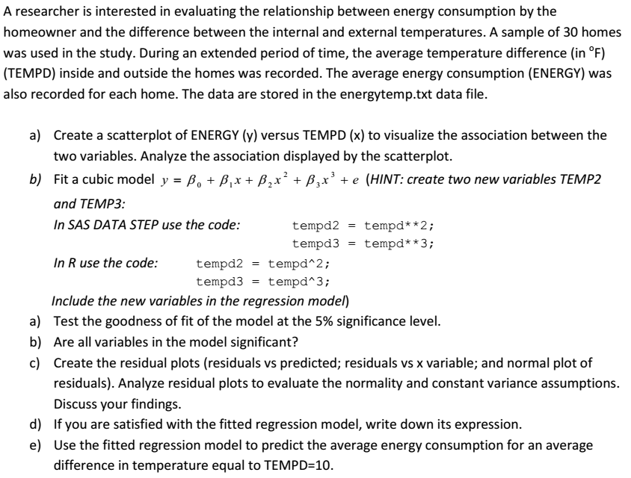 In R, you should use new = data.frame (tempd=c(10), tempd2=c(100), tempd3=c(1000)),   
 and then use the predict() function in R to produce predictions and confidence interval

f) By using influence.measures() function to identify whether there are influential points that can affect your final model. Use cook’s distance as the metric to identify the influential points

**Problem 2 [50]**

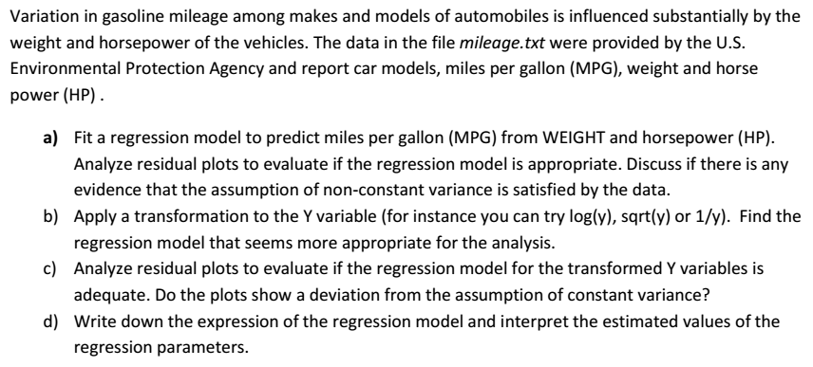 e). Use the step function to adopt both backward and stepwise forward selection to build a   
 new model, compare the new model with the previous model in terms of the adj-R2 value.

**Problem 3 [10]**

Answer the following concept questions.

1). What are the differences between outliers and influential points in linear regression models

2). How to identify a 2nd order and 3rd order terms in linear regression